ASSIGNMENTS

1. **LINKEDIN PROFILE**

URL: <https://www.linkedin.com/in/swetha-r-8075a8281>

1. **BRAND LOGO AND BRAND NAME PROMOTION ON FACEBOOK**

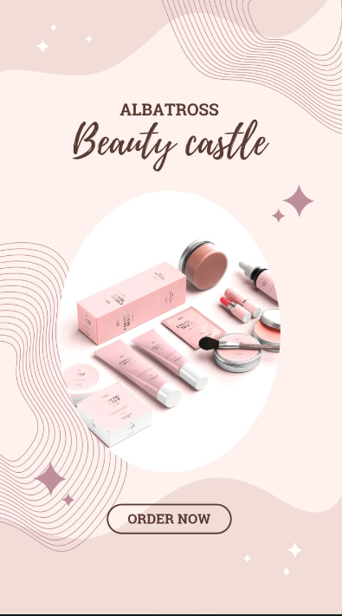

BRAND LOGO

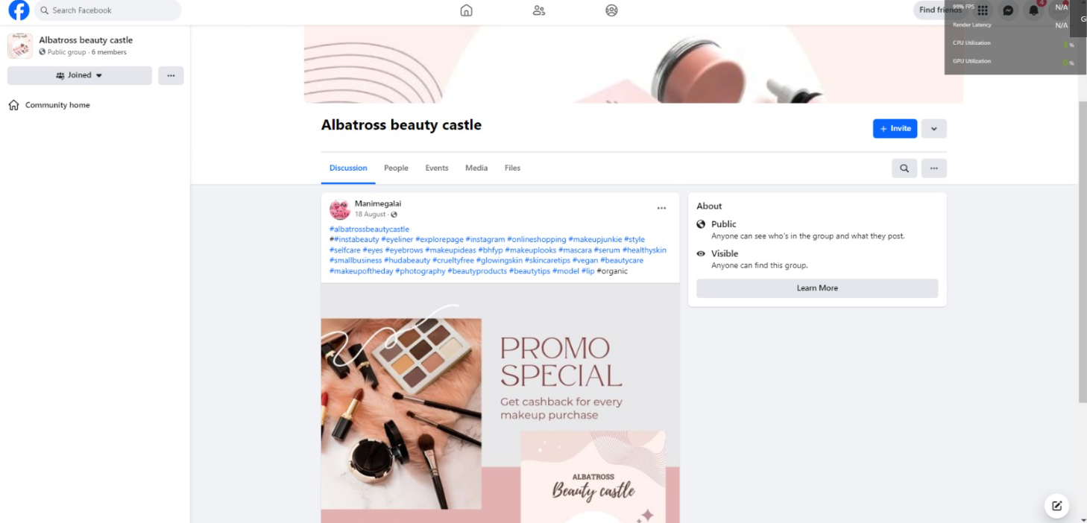

BRAND NAME PROMOTION ON FACEBOOK

1. **BLOGGER WEBSITE**

URL:<https://albatrosswe.blogspot.com/?m=1>

1. **EMAIL NEWSLETTER**

URL:<https://photos.app.goo.gl/KbxCx4BTEtWPkZfG7>

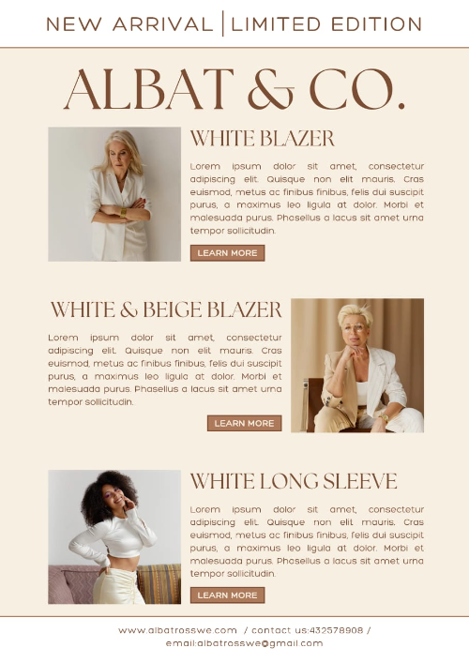

1. **INFOGRAPHICS**

URL :<https://photos.app.goo.gl/G9gYpLDNJN52PZtz7>

